Heart Disease Prediction

Mohith Namburu

SRM University-AP

{ [mohith_namburu@srmap.edu.in](mailto:mohith_namburu@srmap.edu.in) }

Advised by Dr.Rajiv Senapati

# Abstract

Heart disease cases are rising at an alarming rate, and it's critical to be able to predict these diseases in advance. The project focuses on predicting which patients are more likely to have heart disease based on a variety of medical factors. To predict and identify patients with heart disease, we used different algorithms such as Decision tree, Random forest, and KNN. The proposed model's accuracy was quite good, and it was able to predict signs of heart disease in a person. This heart disease predictive method improves patient treatment and makes diagnosing the disease easier along with allowing exploring large data at once.

# Introduction

Data mining is the process of sorting through large data sets to identify patterns and relationships that can help solve business problems through data analysis. g. Data mining provides a set of tools and techniques that can be applied to this processed data to discover hidden patterns. We used a variety of classifiers from supervised and unsupervised learning to predict and determine the dataset's accuracy. Cardiovascular diseases refer to various disorders that can affect the heart and circulatory system. Heart disease has been common for a long time and is still one of the most severe diseases today. According to WHO, cardiovascular diseases(CVDs) are the number 1 cause of death globally. Four out of 5 CVD deaths are due to heart attacks and strokes, and one-third of these deaths occur prematurely in people under 70 years

of age. Our research can identify people who are more likely to be diagnosed with heart disease based on their medical history. It predicts based on factors like sugar level, blood pressure, chest pain, cholesterol, etc. This way, people will be able to know about themselves beforehand and take necessary precautions. To verify the accuracy and explore different models, we used the classifiers KNN, Decision Tree, and Random Forest models.

We used a dataset of people with and without heart disease to predict heart disease. We used 14 different attributes of a patient to predict if they are susceptible to heart disease. The more efficient of these algorithms is Random Forest which gives us the best accuracy. We used many graphical representations to present the results of the project’s predictions and such. This project was inspired by a significant amount of work on the detection of CVDs using data mining. Data mining has been used to make several efficient heart disease predictions. Using the previous and current data mining and clustering techniques, the model incorporating IHDPS was able to predict the likelihood of a person getting heart disease pretty accurately. It focused on basic attributes like age, sex, blood pressure, and blood sugar. But new models which use data mining and neural networks are more efficient, accurate and reliable. A new neural network model had the classification power of 77% to correctly classify the presence of Coronary

Heart Disease (CHD) and 81.8% to accurately classify the absence of CHD cases on testing data, which is 85.70% of the total of their dataset.

# Dataset

We collected the dataset from Kaggle to train the model. The data was gathered from multiple instances. The database is taken from the UCI repository. It initially had 76 attributes but a subset of 14 attributes was used. The dataset includes a variety of individuals and their histories of heart disease, as well as other medical conditions. The dataset consists of the medical history of 1025 different patients of different attributes spread across. This dataset provides details about the patient's medical characteristics, such as age, chest pain types, blood pressure, sugar level, angina, and so on, which enables us in determining whether or not the patient has been diagnosed with heart disease.

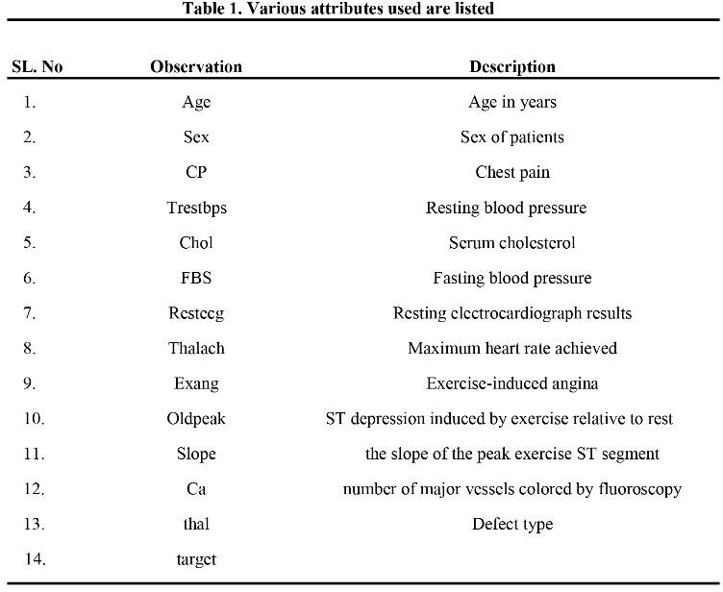

# Methodology

We did an analysis of three Data mining algorithms K nearest neighbors (KNN), Decision Tree, and Random Forest. which are pretty

accurate to this certain predicting model. The proposed approach is organized as follows: the first phase is data collection, the second stage is substantial value extraction, and the third stage is data exploration. Depending on the algorithms used, data preprocessing deals with missing values, data cleaning, and normalization. The classifier used in the proposed models is then used to identify the pre-processed data after it has been pre-processed. Later, we put the proposed model to the test, evaluating it for accuracy and performance using a variety of performance metrics. We used a full dataset to test the model. Percentage of the patient data suffering from heart disease has been calculated and shown using a graphical representation using pie charts to let know the total number of patients with and without heart disease in the used dataset.

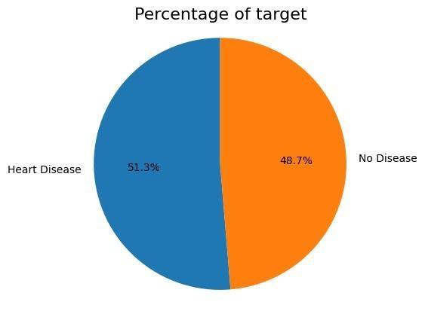

**Flowchart:**

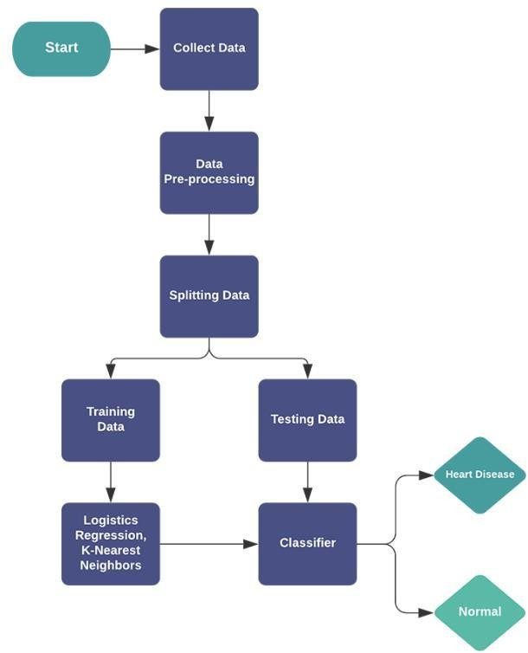

* 1. ***K-Nearest Neighbors:***

K-Nearest Neighbors (KNN) is a nonparametric, lazy, and basic classifier. When all of the characteristics are continuous, KNN is preferred. KNN, also known as case-based reasoning, has been employed in a wide range of applications, including pattern recognition and statistical estimation. To determine the class of an unknown sample, the nearest neighbor must be identified. Because of its rapid convergence speed and simplicity, KNN is favored over other categorization methods.

**Confusion Matrix:**

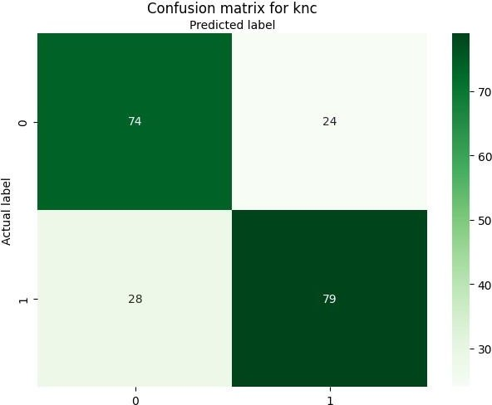

***ROC for KNN:***

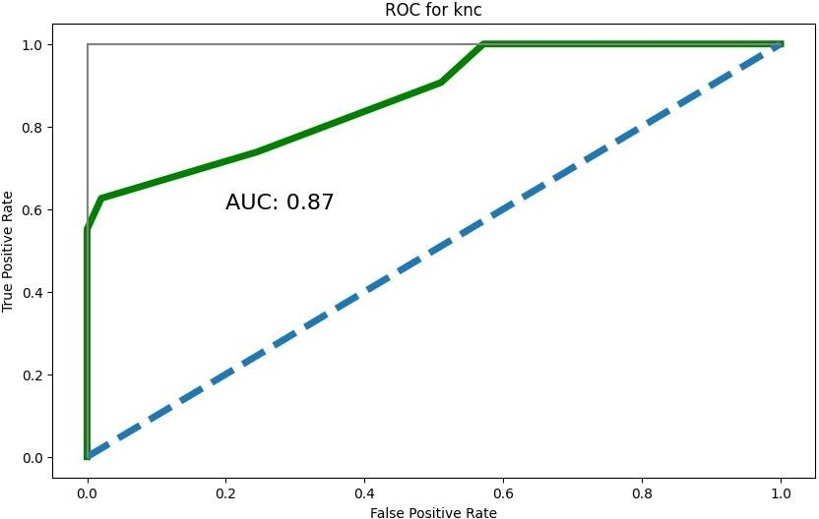

# Decision Tree:

Decision Tree is the most powerful and popular tool for classification and prediction. A Decision

tree is a flowchart-like tree structure, where each internal node denotes a test on an attribute, each branch represents an outcome of the test, and each leaf node (terminal node) holds a class label.

# Confusion Matrix:

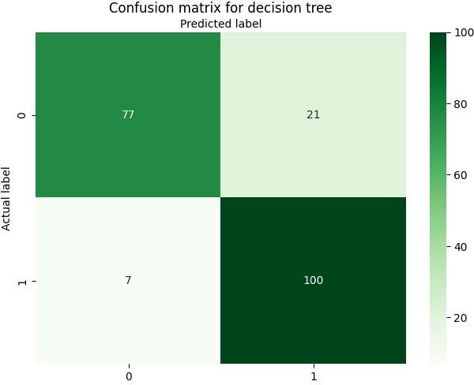

**ROC for Decision Tree:**

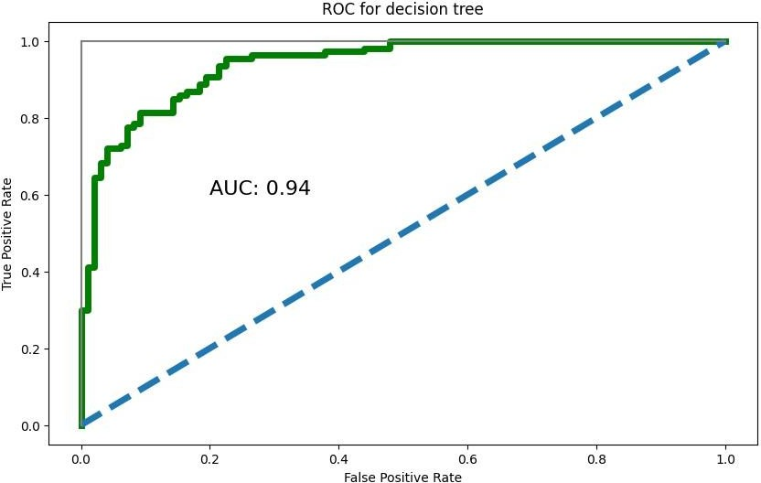

# Random Forests:

Random forests or random decision forests is an ensemble learning method for classification, regression, and other tasks that operates by constructing a multitude of decision trees at training time. For classification tasks, the output of the random forest is the class selected by most trees. For regression tasks, the mean or average prediction of the individual trees is returned.

Random decision forests correct for decision trees' habit of overfitting to their training set.

**Confusion Matrix:**

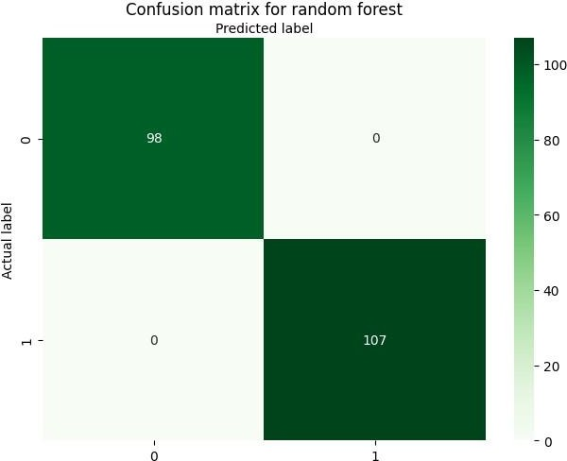

# ROC for Random Forest:

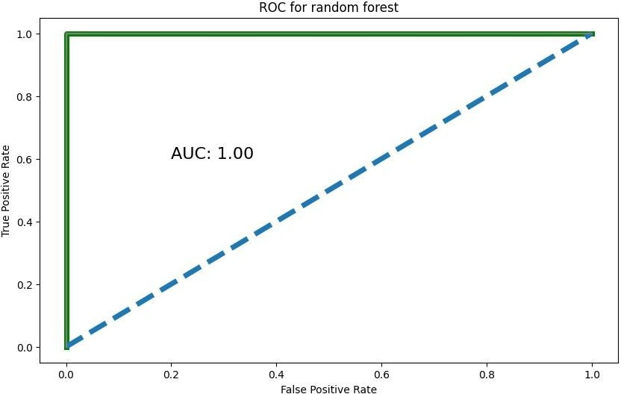

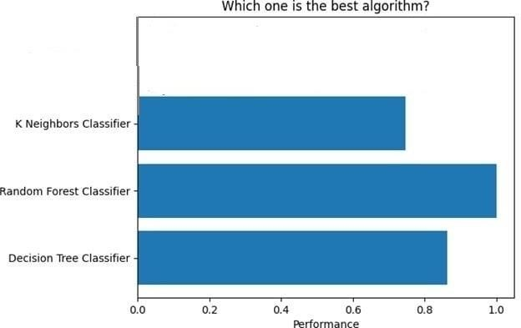**RESULT:**

# CONCLUSION:

Heart disease prediction is challenging and very important in the medical field. However, the mortality rate can be drastically controlled if the disease is detected at an early stage and preventive measures are adopted as soon as possible. The approach has combined the characteristics of the k means clustering decision tree and random forest. In this, we conclude that random forest gives more accurate results in the prediction of heart disease.

# REFERENCES:

1] World Health Organization. (n.d.). Cardiovascular diseases. World Health Organization. [https://www.who.int/health-](https://www.who.int/health-topics/cardiovascular-diseases/) [topics/cardiovascular-diseases/](https://www.who.int/health-topics/cardiovascular-diseases/)

1. Palaniappan,S.,& Awang, R. (2008). Intelligent heart disease prediction system using data mining techniques. 2008 IEEE/ACS International Conference on Computer Systems andApplications. <https://doi.org/10.1109/aiccsa.2008.4493524>
2. Dutta,A., Batabyal,T.Basu ,M., & Acton, S. T. (2020). An efficient convolutional neural network for coronary heart disease prediction. Expert Systems with Applications, 159, 113408. <https://doi.org/10.1016/j.eswa.2020.113408>
3. Ronit, R. (2018, June 25). Heart Disease UCI. Kaggle.

<https://www.kaggle.com/ronitf/heart-disease-uci>

1. Janosi , A., Detrano , R., Pfisterer , M., & Steinbrunn , W. (1988). UCI Machine Learning Repository: Heart Disease Data Set. [https://archive.ics.uci.edu/ml/datasets/Heart+Dis](https://archive.ics.uci.edu/ml/datasets/Heart%2BDisease/) [ease/.](https://archive.ics.uci.edu/ml/datasets/Heart%2BDisease/)